Relax Challenge Write Up

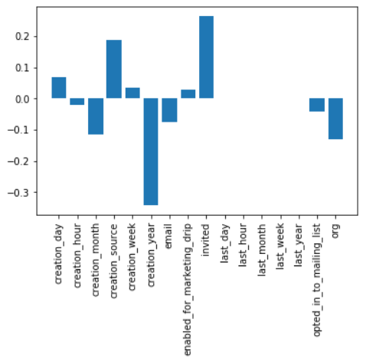In order to find out which factors were most important in determining if a user will become adopted or not, I used a logistic regression. The model is not very predictive, achieve an AUROC of only .6. However, the model is still useful for identifying most important features via coefficients. Here is a plot of coefficients:

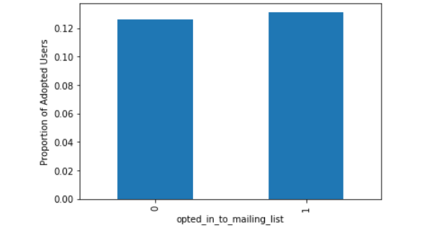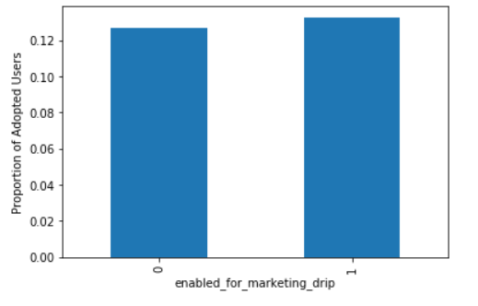As you can see, creation source, creation year, whether or not a user was invited, and organization are the most important variables in the model. Being on the mailing list or marketing drip apparently has no effect on adopting users, which means Relax should look into improving marketing efforts.

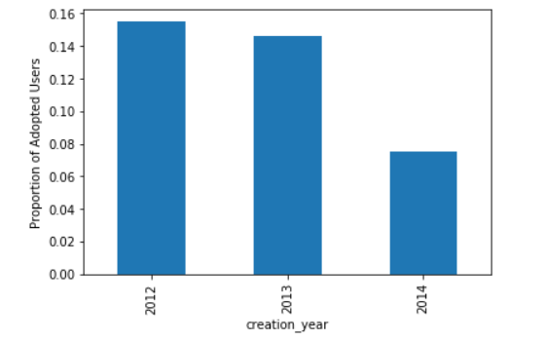Interestingly, people who created their Relax account have a much lower adopting rate. It is worth looking into what happened in 2014 to cause the large drop in adoption.

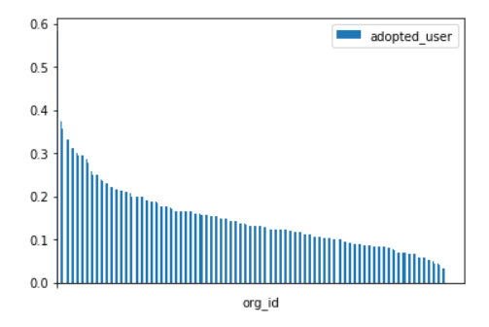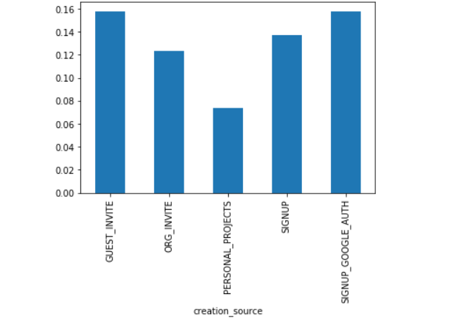The creation source of account is a good predictor of adoption rate. Guest invites, organization invites, and signup all lead to higher user adoption than Personal Projects. Organization of a user is mildly predictive, but there aren’t really a strong group of outlying organizations that have much higher adoption rate.